**Tribhuvan University**

**Faculty of Humanities and Social Sciences**

**A PROJECT REPORT**

**“Car Rental Portal”**

**Submitted to**

**Department of Computer Application**

**Bhairahawa Multiple Campus**

*In partial fulfillment of the requirements for the Bachelors in Computer Application*

**SUBMITTED BY:**

your name

TU Registration No: xxxxx-xx

Under the Supervision of

Teacher Name:”.”

February 2025

**Tribhuvan university**

**Faculty of Humanities and Social Science**

**Bhairahawa Multiple Campus**

# Supervisor’s recommendation

I hereby recommend that this project prepared under my supervision by Manish entitled “**Car Rental Portal”** in partial fulfillment of the requirements for the degree of Bachelor of Computer Application is recommended for the final evaluation.

………………

**SIGNATURE**

**Teaching Assistant**

Bhairahawa Multiple Campus

**Tribhuvan university**

**Faculty of Humanities and Social Science**

**Bhairahawa Multiple Campus**

# LETTER OF APPROVAL

This is to certify that this project prepared by “.” entitled “ **Car Rental Portal**” in partial fulfillment of the requirements for the degree of Bachelor in Computer Application has been evaluated. In our opinion it is satisfactory in the scope and quality as a project for the required degree.

|  |  |
| --- | --- |
| ……………………..  **Campus Chief**  Bhairahawa Multiple Campus | |
| …………………    **Program Coordinator**  Bhairahawa Multiple Campus | …………………    **Supervisor**  Bhairahawa Multiple Campus |
| ……………………  **Internal Examiner**  Bhairahawa Multiple Campus | ………………….  **External Examiner**  Tribhuvan University |

# ACKNOWLEDGEMENT

I am deeply grateful to several individuals whose support, suggestions, and guidance have played a key role in organizing and finalizing this project. Their continuous encouragement has been invaluable in bringing this project to completion, and I would like to take this opportunity to thank them all.

First and foremost, I would like to express my sincere thanks to my supervisor, for giving me the honor of working on this project, "**Car Rental Portal**" whose guidance, insightful feedback, and constant encouragement have been crucial to the success of this project. Without his support, this project would not have reached its final form. I am also thankful for the many new things I learned throughout the process.

I am equally grateful to my family and friends for their endless support and motivation. Their innovative ideas and constant help have been a source of inspiration and encouragement throughout the development of the project. I am thankful for their belief in my abilities, which kept me going even during challenging times.

Finally, I would like to express my gratitude to everyone who has been part of this journey, offering help, guidance, and encouragement. Their assistance has played a crucial role in the successful completion of this project, and I am truly thankful for their support.

With heartfelt thanks.

# STUDENT’S DECLARATION

We hereby declare that the project report entitled “Car Rental Portal” submitted in partial fulfillment of requirement for the Bachelor’s degree of Bachelor in Computer Application of Tribhuvan University is our original work and has not been submitted for the award of any other degree, diploma, fellowship or other similar title or prize.

………………..

“your name”

# ABSTRACT

The Car Rental Portal is a web-based platform that enables customers to book cars. This system collects customer details during the registration process, allowing them to browse available cars and reserve a cars that meets their needs. The online nature of the platform eliminates the need for physical visits, providing a convenient and efficient way to rent cars.

The traditional car rental process relied on manual record-keeping, which was time-consuming and prone to errors. Locating available vehicles required significant effort, often leading to delays and inefficiencies. Managing bookings, tracking vehicle availability, and maintaining customer records manually made the process complex and difficult to scale. To address these challenges, this automated system was developed to enhance efficiency and improve the overall rental experience.

This project aims to digitize and streamline all aspects of car rental management, including maintaining a database of available vehicles, tracking bookings, calculating rental charges, and securely storing customer details. The system allows real-time updates, ensuring that businesses can monitor bookings and vehicle status instantly. It also enables customers to check availability, compare pricing, and make informed decisions.

The Car Rental Portal is an all-in-one solution that simplifies the daily operations of car rental businesses. By automating the booking process, it reduces administrative workload and minimizes errors. Additionally, the system offers secure data management, allowing businesses to access customer records at any time for improved service and decision-making.

This portal is an innovative and user-friendly solution that enhances business operations and customer experience. By leveraging technology, it provides a more organized, efficient, and scalable approach to car rentals, ultimately supporting business growth and improving service quality.

Keywords: Car Rental Portal, Online Car Booking, Rental Management, Customer Management, Automated System, Business Efficiency

**Table of Contents**

Supervisor’s recommendation i

LETTER OF APPROVAL ii

ACKNOWLEDGEMENT iii

STUDENT’S DECLARATION iv

ABSTRACT v

List of Abbreviations viii

List of Figures ix

List of Tables x

Chapter 1: Introduction 1

1.1 Introduction 1

1.2 Problem Statement 1

1.3 Objectives 1

1.4 Scope and Limitations 2

1.5 Report Organization 2

Chapter 2: Background Study and Literature Review 4

2.1 Background Study 4

2.2 Literature Review 4

2.2.1 Technological Frameworks 4

2.2.2 User Experience and Usability 5

2.2.3 Security and Privacy 5

2.2.4 Challenges and Future Directions 5

Chapter 3: System Analysis and Design 6

3.1 System Analysis 6

3.1.1 Requirement Analysis 7

3.1.2 Feasibility Analysis 8

3.1.3 Data Modelling (ER-diagram) 9

3.1.4 Process Modeling (DFD) 11

3.2 System Design 14

3.2.1 Architectural Design 14

3.2.2 Database Schema Design 14

3.2.3 Interface Design 15

3.2.4 Physical DFD 17

Chapter 4: Implementation & Testing 18

4.1 Implementation 18

4.1.1 Tools Used 18

4.1.2 Implementation Details of Modules 18

4.2 Testing 19

4.2.1 Test Cases for Unit Testing 19

4.2.2 Test Cases for System Testing 22

Chapter 5: Conclusion and Future Recommendations 24

5.1 Lesson Learnt 24

5.2 Conclusion 24

5.3 Future Recommendations 25

Appendices 26

References 30

# **List of Abbreviations**

CASE: Computer-Aided Software Engineering

CRUD: Create, Read, Update, Delete

CSS: Cascading Style Sheets

DFD: Data Flow Diagram

ER: Entity Relationship

HTML: Hypertext Markup Language

SQL: Structured Query Language

UI: User Interface

VS Code: Visual Studio Code

# **List of Figures**

Figure 3.1: Waterfall Model 6

Figure 3.1.1.1: Use Case Diagram 7

Figure 3.1.2.4: Gantt Chart 9

Figure 3.1.3: ER Diagram 10

Figure 3.1.4.1: Context Level DFD 11

Figure 3.1.4.2: Level 1 DFD 12

Figure 3.1.4.3: Level 2 DFD 13

Figure 3.2.1: Architectural Design 14

Figure 3.2.2: Database Schema Design 15

Figure 3.2.3.1: Home Page 16

Figure 3.2.3.2: Register Page 16

Figure 3.2.3.3: Login Page 17

Figure 3.2.4: Physical DFD 17

Figure i: Login Page 27

Figure ii: Register Page 27

Figure iii: Home Page/Index Page 28

Figure iv: Home Page after login 29

Figure v: Booking Page 29

Figure vi: Admin Dashboard 30

# **List of Tables**

Table 4.2.1.1: Test Case for Login……………………………………………………..19

Table 4.2.1.2: Test Case for Signup……………………………………………………20

Table 4.2.1.3: Test Cases for Payment………………………………………………….21

Table 4.2.1.4: Test Cases for Booking…………………………………………………21

Table 4.2.2: System Test Cases…………………………………………………………23

# Introduction

## Introduction

The Car Rental Portal is an online system developed to make it easier for customers to rent cars. Through this platform, customers can view available cars, register on the website, and book a car they need. The system collects essential details from users to complete the booking process. In the current manual system, managing car bookings and availability takes a lot of effort and time. Finding which cars are available for rent can be challenging, and maintaining booking records is even harder. This project aims to automate these tasks, making car rental management simple and efficient. With this system, customers can search for available cars, make reservations, and return cars conveniently. Admins can add or remove cars, approve or reject bookings, manage returns, and view customer feedback. It’s a complete solution for managing car rentals and customer records online. The Car Rental Portal saves time, reduces effort, and provides a better experience for both customers and admins, helping businesses streamline their operations and make informed decisions for growth.

## Problem Statement

Managing a car rental business involves various tasks such as vehicle inventory management, customer bookings, tracking rental schedules, and processing payments. Handling these operations manually can be time-consuming, prone to errors, and inefficient. A user-friendly, web-based car rental system is needed to automate and streamline these tasks. The system should help rental companies manage their fleet, process customer bookings, track rentals, and handle payments efficiently, while providing customers with a convenient way to browse available cars and make reservations online.

## Objectives

* To develop a user-friendly web-based car rental system.
* To digitalize the car rental system in order to reduce the manual workload, minimize errors and enhance efficiency.
* To automate and streamline key operations such as vehicle inventory management, customer bookings and payment processing.

## Scope and Limitations

1. **Scope**

* **User Authentication:** Secure login and logout functionality ensures authorized access to the application.
* **User-Friendly Design:** The design of the system or portal is simple and user-friendly.
* **Car List and Booking:** Allows users to see for available cars, make bookings easily and securely.

1. **Limitations**

* **Limited Third-Party Integration:** Integration with external tools or services, such as navigation apps or payment gateways, is not fully implemented, which may limit advanced functionalities.
* **Limited Language Support:** The initial version supports a limited number of programming languages.
* **Profile Update Restriction:** Users cannot update their profile information after registration, which may limit flexibility for making changes.
* **Single Admin Role:** The project supports only one admin role, restricting the ability to assign multiple administrators or role-based permissions.

## Report Organization

The first part of the report gives a brief introduction to the project. It outlines the purpose of the system, its scope, and limitations. This section also presents the problem statement and defines the goals the project aims to achieve, such as providing a seamless car booking and rental experience for users while ensuring secure and efficient management for administrators. The second part provides an overview of the project's context. It explains key concepts related to car rental systems, such as user registration, car booking, payment processes, and logout mechanisms. Additionally, this section reviews existing car rental systems and highlights how this project differs in terms of features, usability, and security. It also discusses the inspiration and motivation behind developing the system.

The third part talks about how the system was planned and designed. It explains the features the project needed, using diagrams like use case diagrams and system diagrams. It also includes a study to see if the project was technically possible, affordable, and useful. This section describes how the system was designed, including the database schema design, diagrams like ER diagrams and Data Flow Diagrams (DFD), and the user interface.

The fourth part focuses on building and testing the system. It lists the tools, programming languages, and database platforms used. It also explains how the system was tested to make sure everything worked correctly.

The final part concludes the report. It summarizes what was achieved, what was learned, and what could be improved in the future. It also includes suggestions for adding more features later.

# Background Study and Literature Review

## Background Study

When comparing the proposed **Car Rental Portal** with existing Nepali car rental websites like Rent in Nepal, Spark Car, and **Sajilo Rental,** there are several key differences. Websites like **Rent in Nepal** offer a range of vehicles, but their booking process can be slow and lacks advanced features, such as filters for car type, price, or availability. The proposed system would improve this by providing an easy-to-use interface, faster booking, and more advanced search options.

**Spark Car** is user-friendly but still lacks detailed filters and secure online payment options, relying mostly on cash payments. The proposed system would offer more flexibility with online payments and allow users to search for cars based on multiple criteria. Similarly, **Sajilo Rental** has a modern website, but it doesn’t offer advanced features like user profiles, booking history, or detailed car comparisons. The **Car Rental Portal** would add these features, making it easier for users to track their rentals and compare options.

Overall, while the current websites provide basic car rental services, the proposed system would improve user experience by offering a smoother booking process, secure payment options, and more helpful tools for both users and administrators.

## Literature Review

Previous studies on car rental systems show that earlier methods relied heavily on manual processes. However, this manual approach had several drawbacks:

* Data was often inaccurate
* Reports lacked detail and reliability
* The process was slow, tedious, and often inefficient
* Going back to check or correct data made it even more cumbersome.
* There was a high risk of data loss or theft.

### Technological Frameworks

A substantial body of research has explored the technological foundations of web-based car rental systems. According to Sharma *et al.[1]*, these portals often integrate dynamic web development technologies such as HTML5, CSS3, JavaScript, and backend frameworks like PHP or Node.js, supported by databases like MySQL. Cloud computing and APIs further enhance scalability and interconnectivity [2].

A substantial body of research has explored the technological foundations of web-based car rental systems. For instance, Ogbiti and Aaron [2] developed a web-based car rental management system, highlighting the integration of dynamic web development technologies. Additionally, Nasr et al.[3] proposed a car rental and tracking web-based system using GPS, emphasizing the importance of real-time tracking in enhancing service delivery.

### User Experience and Usability

User experience (UX) plays a critical role in the adoption of web-based car rental platforms. Tuyambaze et al. [4] developed an intelligent mobile application based on a cloud-integrated information system for car rental services, emphasizing the importance of intuitive interfaces and personalized user journeys. Features such as real-time vehicle availability, cost estimation, and secure payment gateways have been identified as pivotal in enhancing user satisfaction.

### Security and Privacy

Security and privacy concerns are central to the development of web-based car rental systems. Luo et al. [[4] proposed an anonymous car rental system based on NFC, addressing common threats such as data breaches and insecure payment processes. The integration of SSL encryption, secure authentication mechanisms, and compliance with regulations are critical in mitigating these risks.

### Challenges and Future Directions

Despite their advantages, web-based car rental portals face challenges such as competition, cybersecurity threats, and varying customer expectations. The literature suggests leveraging artificial intelligence (AI) and machine learning (ML) to provide smarter recommendations and predictive analytics. Furthermore, integrating block chain for transparent and secure transactions has been proposed as a promising avenue [5].

# System Analysis and Design

## System Analysis

System Analysis refers into the process of examining a system with the intent of improving it through better procedures and methods. It is the process of planning a new system to either replace or complement an existing system. It is, therefore, the process of gathering and interpreting facts, diagnosing problems and using the information to re- comment on improvements in the system.

System analysis is conducted with the following objectives in mind:

* Evaluate the system concept for feasibility.
* Perform economic and technical analysis.
* Allocate functions to hardware, software people, database and other system elements.

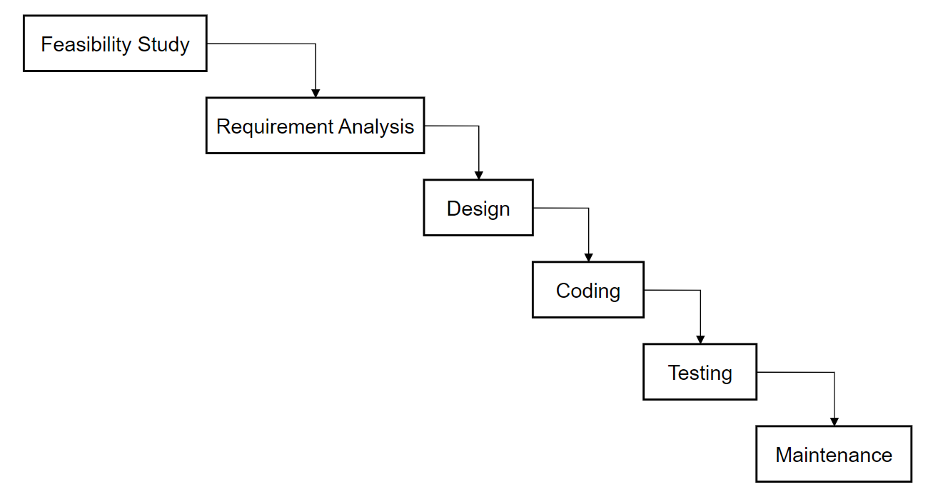

Figure3.1: Waterfall Model

### Requirement Analysis

Requirement analysis involves refining and prioritizing the collected requirements to ensure they align with the project’s objectives and constraints. This process includes:

#### Functional Requirements

* User Authentication: Users should be able to sign up, log in, and log out.
* CRUD Operations: Users can create, read and Admin update, and delete.
* Admin Management: Admins can add cars , bookings request, User’s Management.
* Car Booking : Registered users can book cars online and view their booking Status.
* Payment Module User should be able to make payment by filling Card Details.

**Use Case Diagram**

A use case diagram is a graphical representation used in software engineering to illustrate the interactions between users (actors) and a system. It captures the functional requirements of a system, showing how different users engage with various functionalities within the system.

**Car Rental Portal**

**Users**

**Admin**

#### Non-Functional Requirements

Non-Functional Requirements describe the general properties of a system. They are among the most important things to define when building the specification for code snippet saving platform, as most have a direct impact on the experience and satisfaction of your users.

Here are some basic types of nonfunctional requirements:

* **Security:** It should be secure, allowing only the authorized users to access and manage their snippets.
* **Usability:** The user interface should beminimal and intuitive, allowing users to easily navigate to different components of the application.
* **Responsiveness**: The app should be fully functional on both desktop and mobile devices.
* **Performance**: The application should have fast response time.

### Feasibility Analysis

#### Technical Feasibility

The required technology stack (i.e., web technologies, database systems) is readily available and well-supported.

#### Operational Feasibility

Skills, time management, and maintenance plans are feasible, with strategies in place for user adoption.

#### Economic Feasibility

The web app does not require extra software and hardware i.e. it uses free and open-source technologies. So, there is no recurring cost than just the internet connection.

#### Schedule

This includes the project schedule, and all the time allocated for its completion. The Gantt chart is as follow:

Figure System Analysis and Design.1.2.4: Gantt Chart

### Data Modelling (ER-diagram)

Data models define how data is connected to each other and how they are processed and stored in a system. There are different data models which are used to design and develop the database, but here we use ER (Entity Relationship) Model.

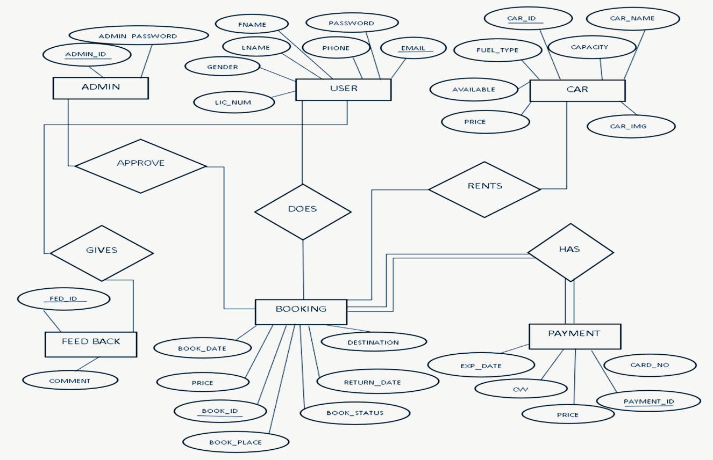

Figure System Analysis and Design.1.3: ER Diagram

The above ER diagram represents a car rental portal with six main entities.

* **ADMIN**: Represents the administrators of the system, with attributes like **ADMIN_ID** (username) and **ADMIN_PASSWORD** (password).
* **CAR:** Represents the cars available for rental, with attributes like **CAR_ID** (unique ID), **CAR_NAME** (name of the car), **CAPACITY** (seating capacity), **AVAILABLE** (availability status), **PRICE** (rental price), **FUEL_TYPE** (fuel type), and **CAR_IMG** (image of the car).
* **USER**: Represents the customers of the system, with attributes like **FNAME** (first name), **LNAME** (last name), **EMAIL** (email address), **PASSWORD** (login password), **GENDER** (gender), **PHONE** (phone number), and **LIC_NUMBER** (license number).
* **BOOKING**: Represents the booking information, with attributes like **BOOK_ID** (unique booking ID), **BOOK_PLACE** (place of booking**), BOOK_DATE** (date of booking), **PRICE** (rental price), **DESTINATION** (destination), **RETURN_DATE** (return date), **CAR_ID (**foreign key linking to the CAR entity), and **EMAIL** (foreign key linking to the USER entity).
* **PAYMENT:** Represents the payment details, with attributes like **PAYMENT_ID** (unique payment ID), **CARD_NO** (card number), **EXP_DATE** (card expiry date), **CVV** (card CVV), **PRICE** (rental price), and **BOOK_ID** (foreign key linking to the BOOKING entity).
* **FEEDBACK**: Represents user feedback, with attributes like **FEED_ID** (unique feedback ID), **COMMENT** (user feedback), and **EMAIL** (foreign key linking to the USER entity).

### Process Modeling (DFD)

Process Modeling with DFDs visually represents data flow in a system, showing processes, data stores, and external entities. Level 0 gives a high-level overview, Level 1 breaks it into major processes, and Level 2 details each process. They help understand, design, and document systems effectively.

**Level 0 DFD (Context Diagram)** provides a high-level overview of the system, showing the **User** interacting with the **System**to submit, search, and receive results, without detailing internal processes.

**Car Rental Portal**

**Figure System Analysis and Design.1.4.1: Context Level DFD**

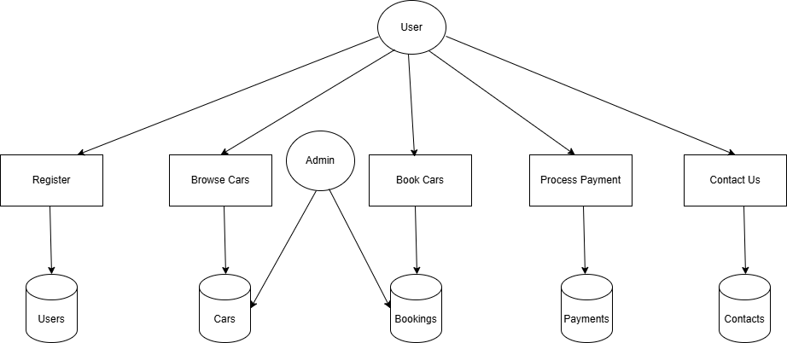

Figure System Analysis and Design.1.4.2: Level 1 DFD

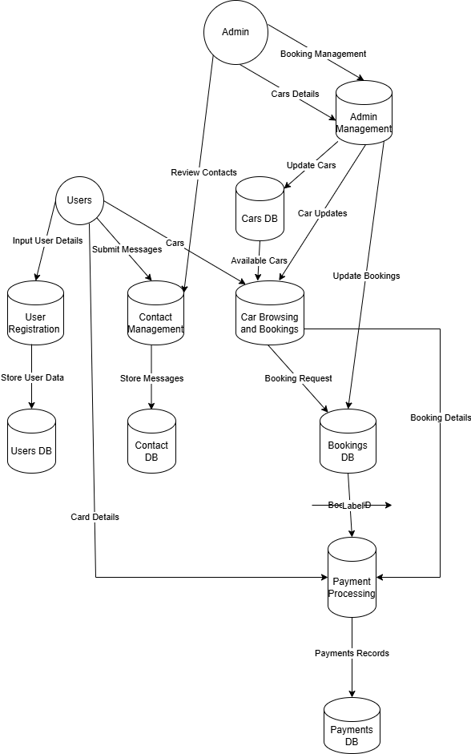

Figure System Analysis and Design.1.4.3: Level 2 DFD

## System Design

### **Architectural Design**

Figure System Analysis and Design.2.1: Architectural Design

### Database Schema Design

The design of the database is called a schema. This tells us about the structural view of the database. It gives us an overall description of the database. A database schema defines how the data is organized using the schema diagram. A schema diagram is a diagram which contains entities and the attributes that will define that schema. A schema diagram only shows us the database design. It does not show the actual data of the database. A Schema can be a single table, or it can have more than one table which is related. The schema represents the relationship between these tables.

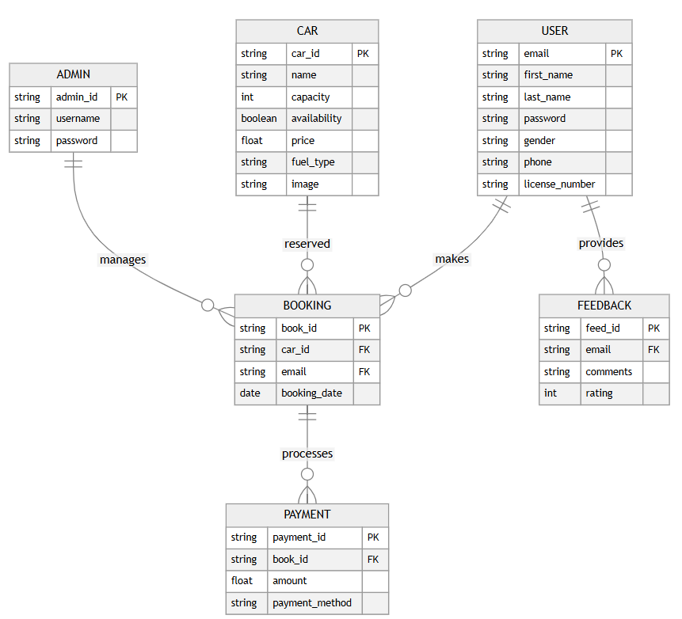

Figure System Analysis and Design.2.2: Database Schema Design

### Interface Design

The interface design is centered around delivering a smooth and user-friendly experience for customers booking and managing car rentals. The target audience includes individuals and businesses looking for an easy and efficient way to rent vehicles online. The platform was developed using PHP, CSS, JavaScript, HTML, and MySQL to ensure functionality, speed, and reliability.

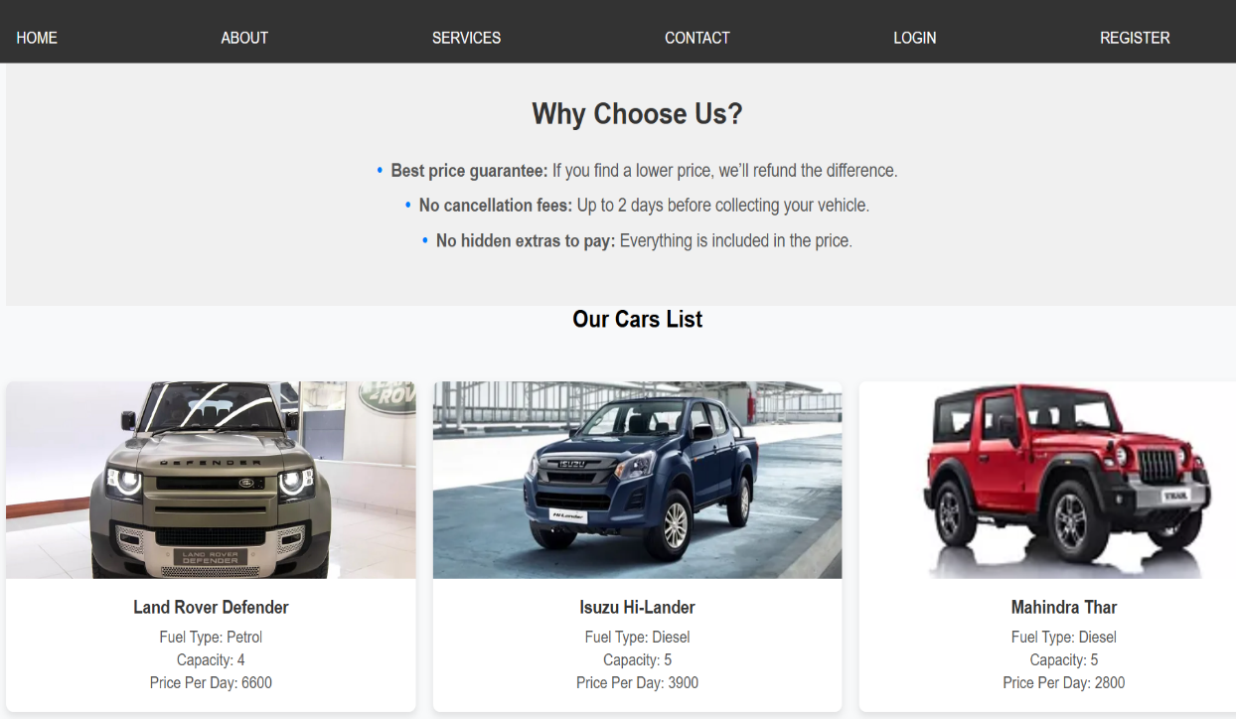

Figure System Analysis and Design.2.3.1: Home Page

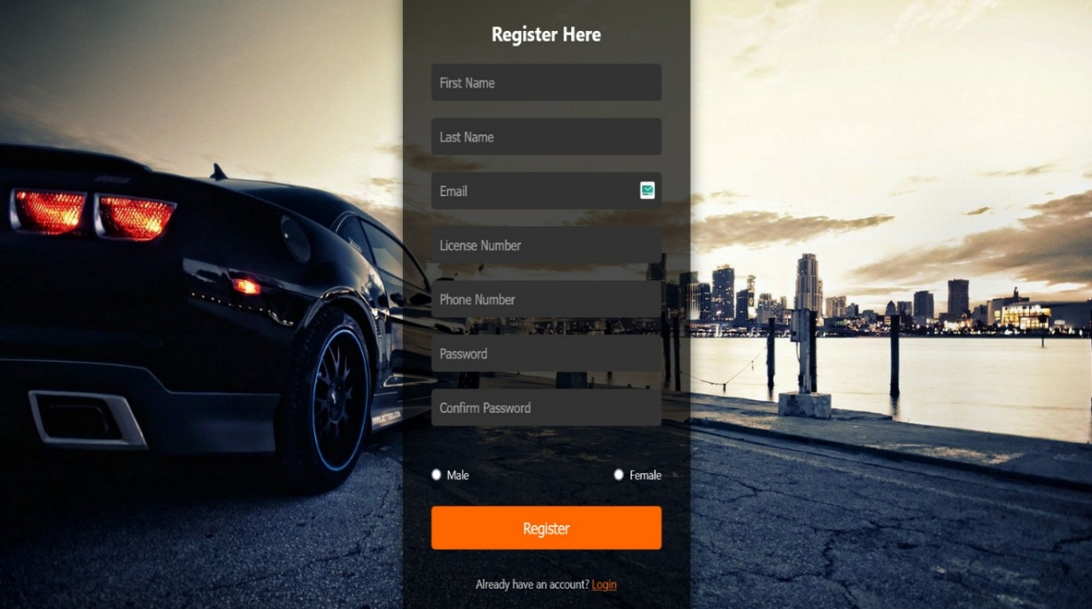

Figure System Analysis and Design.2.3.2: Register Page

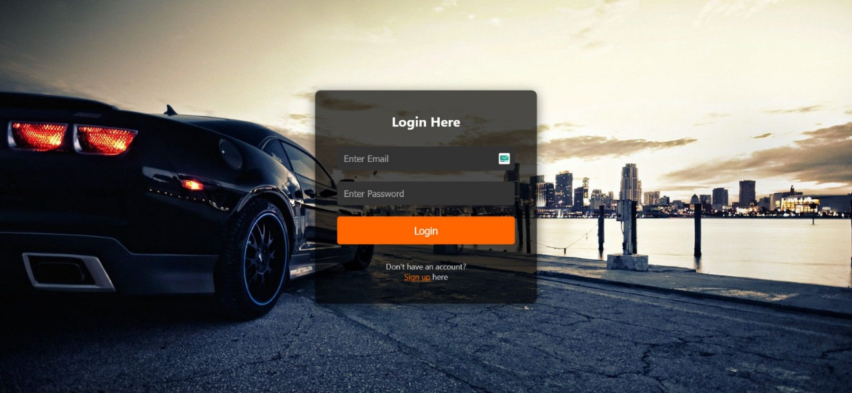

Figure System Analysis and Design.2.3.3: Login Page

### Physical DFD

A **Physical DFD** shows how data flows in a system, focusing on the physical implementation, such as hardware, software, databases, and user interactions. It emphasizes the how and where of data processing, unlike a logical DFD that focuses on the what.

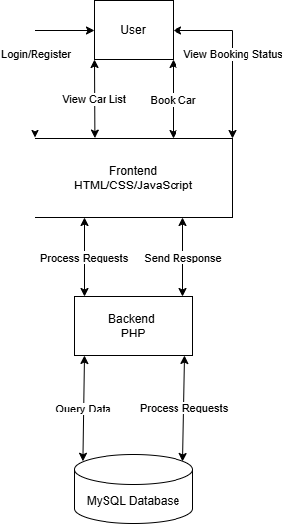

Figure System Analysis and Design.2.4: Physical DFD

# Implementation & Testing

## Implementation

In this phase, the theoretical design is transformed into a functional system. With the design phase complete, the focus now shifts to technical implementation. This involves coding the application based on the system's requirements and specifications.

### Tools Used

#### Programming Languages

* **PHP**: Used for developing the backend with MySQL.
* **JavaScript**: Used for building and logic in frontend
* **HTML & CSS**: Used for structuring and styling the frontend.

#### Database Platforms

* **MySQL**: Serves as the primary database for storing user data, Cars, and related information.

### Implementation Details of Modules

#### Register Module:

* The user needs to provide their first name, last name, email, license number, phone number, password, confirm password, gender for registration.
* These details will be stored in the database.

#### Login Module:

* For login user will input their email and password.
* Admin will provide their admin id and password which will compared with a database content.

#### Booking Module:

* Users can view the list of cars. The booking details of cars are provided by the admin.
* Users can select their preferred car and book for the same.

#### Payment Module:

* Users should be able to make payment by filling card number, expiry date and CVV are provided by the admin.
* After payment user will get the payment successful popup window.

#### Logout Module:

* The system should allow users to logout .
* The system should also allow admin to logout.

## Testing

Testing is a process of executing a program with the intent of finding an error. A good test case is one that has a high probability of finding an undiscovered error. The primary objective for test case design is to derive a set of tests that has the highest livelihood for uncovering defects in software. To accomplish this objective two different categories of test case design are used.

### Test Cases for Unit Testing

Unit Test focuses on verifying the correctness of individual components or units of code, such as a single function, method, or class. They are performed early in the development process to catch bugs at the foundational level and provide developers with immediate feedback on their code.

Table 4.2.1.1: Test Case for Login

|  |  |  |  |
| --- | --- | --- | --- |
| Test cases no | Test Case | Expected results | Status |
| 1 | Logging into website | Email and password provided correct | Successful |
| 2 | Logging into website | Email incorrect | Unsuccessful |
| 3 | Logging into website | Password Incorrect | Unsuccessful |
| 4 | Logging into website | Any field left empty | Unsuccessful |

Result Analysis for Login Test Cases

The login system was tested with different scenarios to ensure proper authentication and error handling. The observations are as follows:

1. Successful Login:

* When the correct email and password were provided, the login was successful.
* This confirms that the system correctly authenticates valid user credentials.

1. Unsuccessful Login Cases:

* Incorrect Email: If the email was incorrect, the login attempt failed.
* Incorrect Password: If the password was incorrect, the login attempt failed.
* Empty Fields: If any field (email or password) was left blank, the system did not allow login.

These failed attempts confirm that the system has proper validation to prevent unauthorized access.

Table 4.2.1.2: Test Case for Signup

|  |  |  |  |  |  |
| --- | --- | --- | --- | --- | --- |
| Test cases no | Test Case |  |  | Expected results | Status |
| 1 | Registration user | for | new | All details provided  correctly | Successful |
| 2 | Registration user | for | new | Any one field is incorrect | Unsuccessful |
| 3 | Registration user | for | new | Any field left empty | Unsuccessful |

RResult Analysis for Signup Test Cases:

* If a new user provided all required details correctly, the registration was successful.
* If any field was left empty or incorrect, the system flagged the issue and prevented signup.
* This ensures that only valid users with complete information can register.

Table 4.2.1.3: Test Cases for Payment

|  |  |  |  |
| --- | --- | --- | --- |
| Test cases no | Test Case | Expected results | Status |
| 1 | Payment | All details provided correctly | Successful |
| 2 | Payment | Any one field is  incorrect | Unsuccessful |
| 3 | Payment | Any field left empty | Unsuccessful |

Result Analysis for Payment Test Cases:

* If all details were provided correctly, the payment was processed successfully.
* When a field was incorrect or left empty, the payment attempt failed, ensuring accuracy in transactions.
* This confirms that the system correctly validates payment details before processing.

Table 4.2.1.4: Test Cases for Booking

|  |  |  |  |
| --- | --- | --- | --- |
| 1 | Booking | All details provided correctly | Successful |
| 2 | Booking | Any one field is incorrect | Unsuccessful |
| 3 | Booking | Any field left empty | Unsuccessful |

ResulResult Analysis for Booking Test Cases:

* When all required details were provided correctly, the booking process was successful.
* If any field was left empty or contained incorrect information, the system prevented the booking and returned an error.
* This indicates that the booking validation system is working properly, ensuring only complete and accurate bookings are processed.

### Test Cases for System Testing

System Test evaluates the entire system or application, including all integrated components and interactions. They are performed after integration and unit testing to confirm that the complete system works seamlessly and delivers the expected user experience.

Table 4.2.2: System Test Cases

|  |  |  |  |  |
| --- | --- | --- | --- | --- |
| Test Case No | Test Case | Test Data | Expected Outcome | Result |
| 1 | ADD Car | Admin Added Cars | Car Added Successfully | Pass |
| 2 | Update Car Price | Admin Updated Cars Prices | Price of Car Updated Successfully | Pass |
| 3 | Delete a User | Admin Deleted User | The user has been removed. | Pass |
| 4 | Allow Booking Request | Admin Approved the Booking Request | Car Approved Successfully | Pass |
| 5 | Deny Booking Request | Admin Denied Booking Request | Car Denied | Pass |
| 6 | Admin Login with Valid Credentials | Email: admin@example.com, Password: Abc123! | Admin is logged in successfully | Pass |
| 7 | Delete Car | Admin Deleted Car | Car Deleted Successfully | Pass |
| 8 | Log in with valid credentials | Email: test@example.com, Password: StrongPass123! | User is logged in successfully. | Pass |
| 9 | Log in with invalid credentials | Email: test@example.com, Password: Wrong Pass | Error message "Invalid credentials". | Pass |

Result Analysis for System Test Cases

The system test cases were executed to evaluate the functionality of the car rental management system. The following observations were made:

1. Car Management:

The system successfully allowed the admin to add, update, and delete cars, confirming that the car management functionality works as expected.

1. User Management:

The admin was able to delete a user successfully, indicating that the system correctly processes user removal requests.

1. Booking Requests:

The admin was able to approve and deny booking requests without issues, ensuring that the booking system operates correctly.

1. Login Functionality:

The system allowed valid users (admin and regular users) to log in successfully.

When incorrect credentials were entered, the system displayed an "Invalid credentials" message, confirming that security measures are in place.

All test cases passed successfully, demonstrating that the system functions as intended. It effectively handles car management, user management, booking approvals, and login authentication. The system is reliable and ready for deployment.

# Conclusion and Future Recommendations

## Lesson Learnt

During the development of the web app, many valuable lessons in full-stack development were learned, from planning to deployment. The backend was built using PHP, focusing on user authentication, and database management. Features like booking, payment and improved the understanding of managing data and user interactions.

On the front end, CSS, HTML were used to create a clean and responsive interface, with prebuilt components speeding up development while allowing customization.

GitHub helped in tracking changes in codes. InfinityFree helped for Deploying the web live on https://carbca.infy.uk

## Conclusion

The Car Rental Portal is designed to allow customers to book cars. This application collects customer details through an online form, enabling registered users to reserve the car they need. It provides a convenient platform where customers can browse available cars, register, and book a car online.

The project was developed to simplify car rental bookings at specified rates. In the current manual system, managing bookings and vehicle records is labor-intensive and time-consuming. Checking vehicle availability is a tedious process, making the entire system inefficient.

The main goal of this project is to automate car rental management tasks, such as maintaining vehicle records, tracking available cars, managing rental charges, and storing customer details. It is a comprehensive car booking software that streamlines daily operations for rental businesses. It allows businesses to store and access customer information online at any time, facilitating better decision-making for business growth. The online car rental portal is an innovative and efficient solution for managing rental services.

## Future Recommendations

While the project successfully meets its core objectives, there are several areas for improvement and expansion to enhance its functionality. Here are some future recommendations:

* **Limited Language Support:** The initial version supports a limited number of programming languages.
* **Profile Update Restriction:** Users cannot update their profile information after registration, which may limit flexibility for making changes.
* **Single Admin Role:** The project supports only one admin role, restricting the ability to assign multiple administrators or role-based permissions.

# Appendices

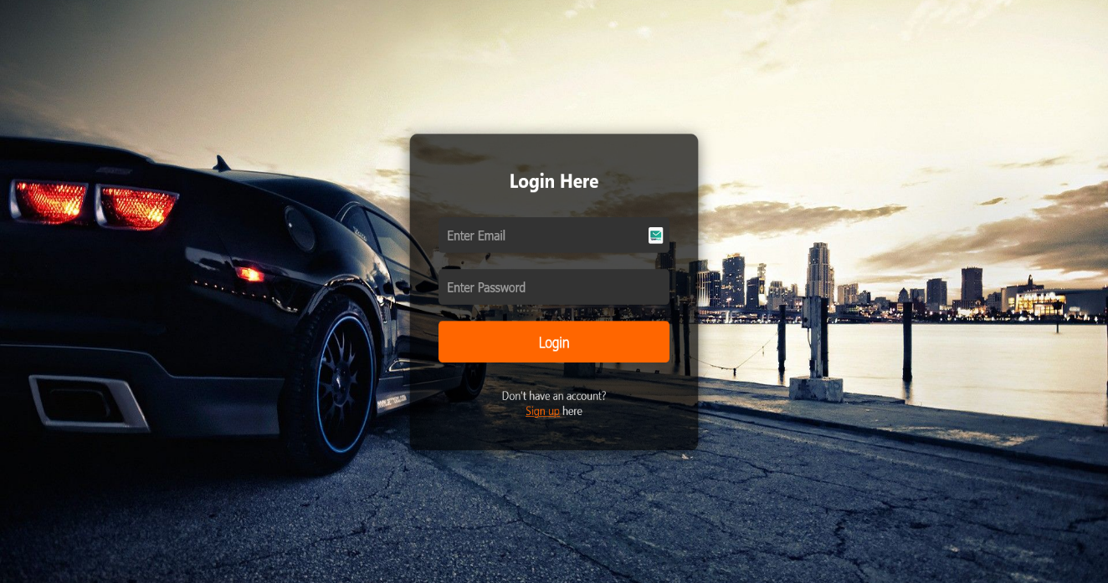

Figure i: Login Page

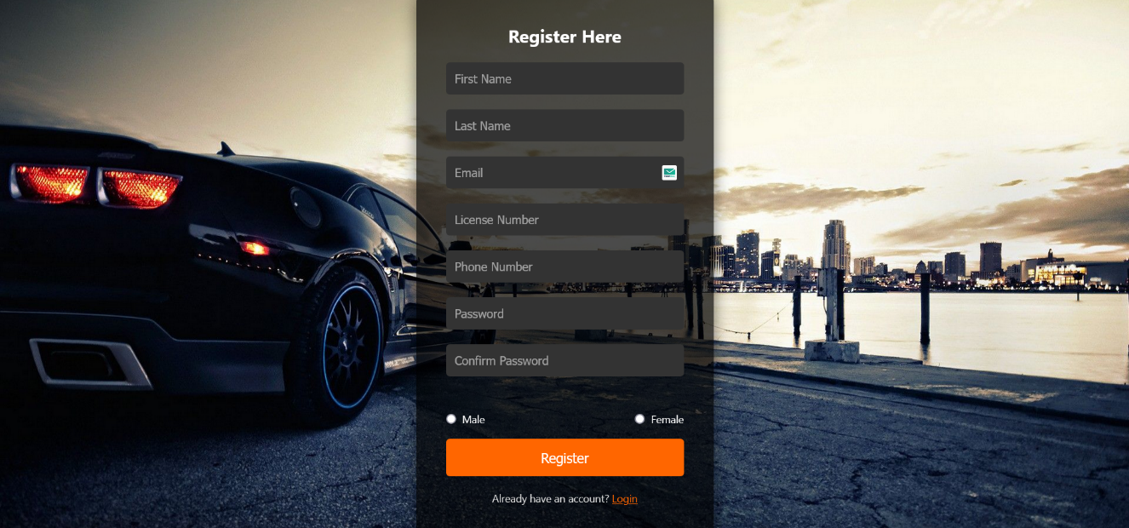

Figure ii: Register Page

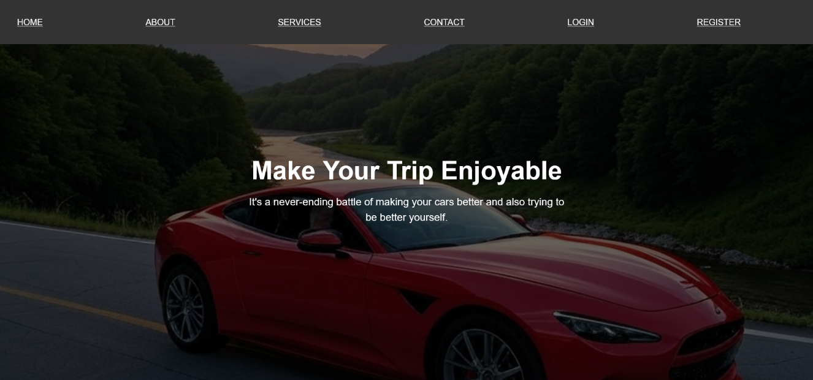

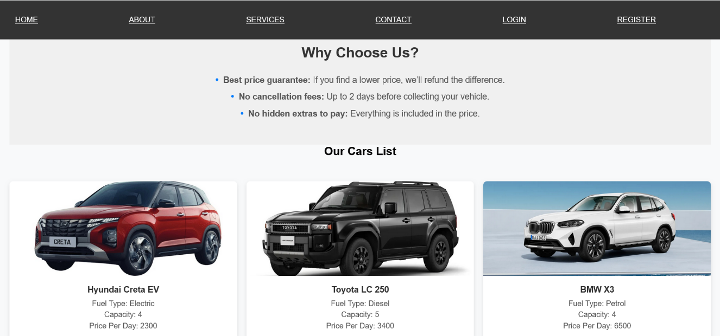

Figure iii: Home Page/ Index Page

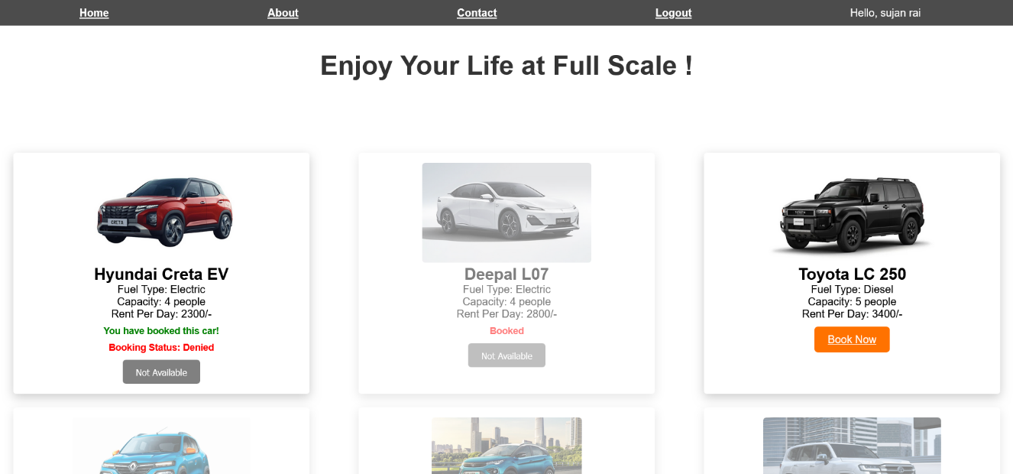

Figure iv: Home Page After Login

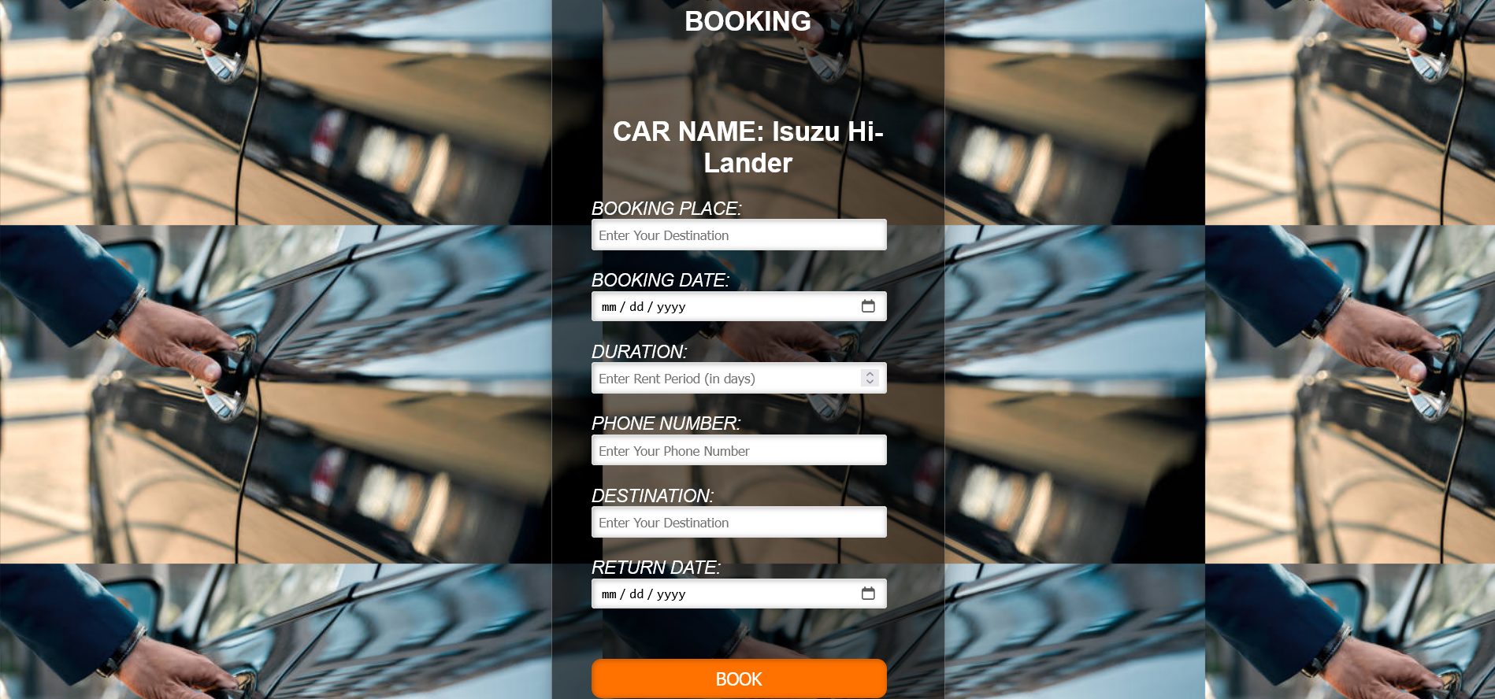

Figure v: Booking Page

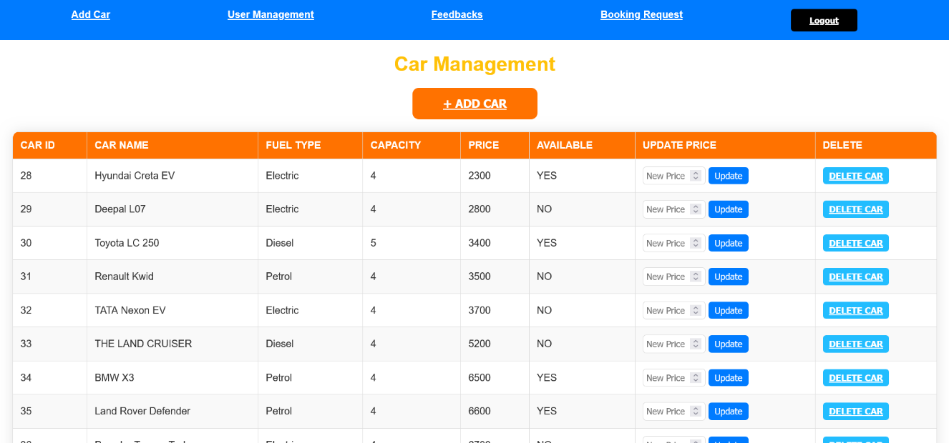

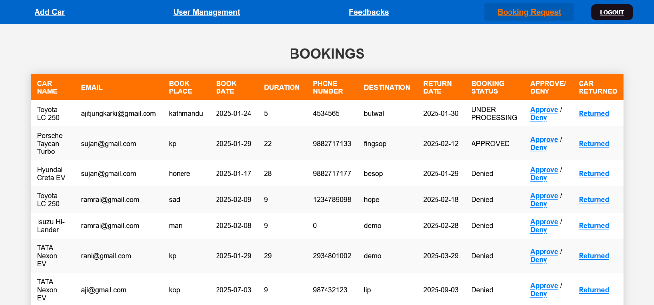

Figure vi: Admin Dashboard

# References ­

[1] Q. Zhang, L. Cheng, and R. Boutaba, “Cloud computing: State-of-the-art and research challenges,” *Journal of Internet Services and Applications*, vol. 1, no. 1, pp. 7–18, May 2010, doi: 10.1007/s13174-010-0007-6.

[2] J. T. Ogbiti and W. Aaron, “Development of a web-based car rental management system,” *Science World Journal*, vol. 19, no. 3, pp. 797–807, Oct. 2024, doi: 10.4314/swj.v19i3.27.

[3] O. A. Nasr, M. N. Miladi, and M. H. Ahmed, “CAR RENTAL AND TRACKING WEB-BASED SYSTEM USING GPS.”

[4] T. Tuyambaze, E. Mkoba, B. Mgawe, and B. Mbunda, “Development of An Intelligent Mobile Application based on A Cloud Integrated Information System for Car Rental Services.,” Apr. 30, 2024. doi: 10.21203/rs.3.rs-4300397/v1.

[5] N. García-Moreno, P. Caballero-Gil, C. Caballero-Gil, and J. Molina-Gil, "Building an Ethereum-based decentralized vehicle rental system," 2022.